**St. Francis Institute of Technology**

**Department of Computer Engineering**

**Academic Year: 2021-2022 Semester: VIII**

**Subject: Cloud Computing Lab Class / Branch / Division: BE/CMPN/A**

Name :-Rebecca Dias Roll Number:18

**Experiment No: 04**

# Aim: Implement study of Platform as a Service(Google App Engine/AWS).

# Theory:

## Prepare a detailed study of Platform as a Service

### What is PaaS?

Platform as a service (PaaS) is an enabler for software development where a third-party service provider delivers a platform to customers so they can develop, run, and manage software applications without the need to build and maintain the underlying infrastructure themselves.

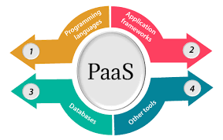

As with other cloud services such as infrastructure as a service (IaaS) and software as a service (SaaS), a PaaS is typically accessed over the internet but can also be deployed on-premises or in a hybrid mode. Regardless, the underlying infrastructure an application runs on is managed by the service provider. In many cases, the customer can decide where their application is physically hosted and is given a choice over how performant or secure that environment is, often at an additional cost.

### How to use PaaS (Customer)

PaaS provides direct support for business agility by enabling rapid development with faster and more frequent delivery of functionality. It does this through continuous integration techniques and automatic application deployment. PaaS also enables developers to realize the cloud’s broader benefits.

### How to provide PaaS (Cloud Service Provider)

When organizations adopt a SaaS solution, they are choosing to outsource their entire technology stack and the associated maintenance costs to a third-party provider. PaaS, in contrast, does not typically replace an organization's entire IT infrastructure, rather, it helps organizations access key services with minimal start-up costs and reduced time to deployment.

## Advantages and Limitation of PaaS

*Advantages of PaaS*

By delivering infrastructure as a service, PaaS offers the same advantages as IaaS. But its additional features—middleware, development tools and other business tools—give you more advantages:

* Cut coding time. PaaS development tools can cut the time it takes to code new apps with pre-coded application components built into the platform, such as workflow, directory services, security features, search and so on.
* Add development capabilities without adding staff. Platform as a Service components can give your development team new capabilities without your needing to add staff having the required skills.

*Disadvantages of Paas*

* Security:All the data of applications are stored inside the provider's cloud database. This brings up confidential issues since the private and sensitive information can be viewed by the provider. As a result, it is the responsibility of the businesses to secure their applications by selecting a trustworthy provider. Otherwise, the existing information could be at risk.
* Control:Users lack some controls over a PaaS solution. It is dependent on the providers capabilities. For an example, whenever the provider increases their pricing scheme similarly the applications could become expensive too. Therefore, it is important to choose your PaaS provider wisely.

## Study security issues in PaaS

PaaS allows companies to build, run and ultimately manage Web applications without the infrastructure that is normally required.

Since PaaS is based on the notion of using shared resources (such as hardware, network, and security provisions), security concerns are usually focused on mission-critical information that hackers can obtain during a data breach. If the PaaS tenants have Administrator/’root’, or shell access to the servers running their instances, additional security issues could arise if hackers are able to gain unauthorized access and change configurations. Additionally, security controls and self-service entitlements offered by the [PaaS platform could pose a problem if not properly configured](https://docs.microsoft.com/en-us/azure/security/fundamentals/paas-deployments). Providers should be able to provide clear policies, guidelines, and adhere to industry-accepted best practices.

Once again, security cannot be solely the PaaS provider responsibility. When selecting a PaaS vendor, consider these crucial issues before final selection:

* What are the types of encryption used?
* What are the data independence and availability? (Can you move your virtual machines and all of their data to another provider? Who has access to it? What happens if a cloud instance migrates to another country?)
* What are the disaster recovery/business continuity protocols?

## Technologies used to provide PaaS

### [Amazon Elastic Beanstalk](https://aws.amazon.com/elasticbeanstalk/)

[@awscloud](https://twitter.com/awscloud)

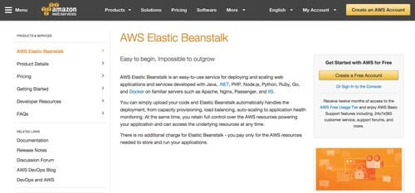

Amazon Elastic Beanstalk gives users an easy way to deploy and provision cloud-based resources that automate setting up applications on Amazon Web Services. All you need is to upload your applications, and everything from load balancing, provisioning, application health monitoring, and auto-scaling will be handled by Amazon Elastic BeanStalk.

### [BitNami](https://bitnami.com/)

[@bitnami](https://twitter.com/bitnami)

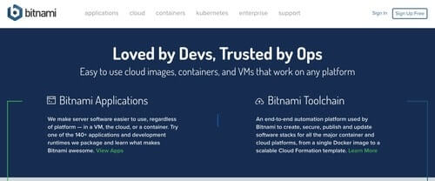

Bitnami enables you to host and run your applications in the cloud. You can have Bitnami stacks deployed and managed easily and quickly. It supports different cloud platforms including Amazon Web Services, Google Cloud Platform, Microsoft Azure, and Oracle Cloud Platform. Apart from cloud services, Bitnami also gives you applications that help deliver the same experience for different users no matter what platform they use: containers, on the cloud, or with a virtual machine.

### [Google App Engine](https://cloud.google.com/appengine/)

[@googlecloud](https://twitter.com/googlecloud)

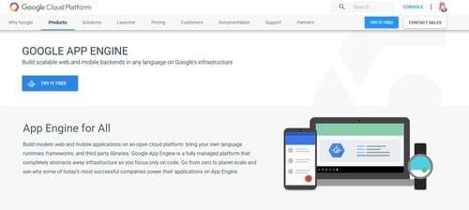

Google App Engine helps you build mobile and Web back-ends using the programming language, frameworks, libraries, and runtimes that you are most comfortable with. Google takes care of the infrastructure while you work on your code. Check out our handy [feature comparison chart](https://stackify.com/microsoft-azure-vs-amazon-web-services-vs-google-compute-comparison/) to compare Google Compute with Azure and AWS.

# 

Activity:

Steps:

Search for Elastic Beanstalk

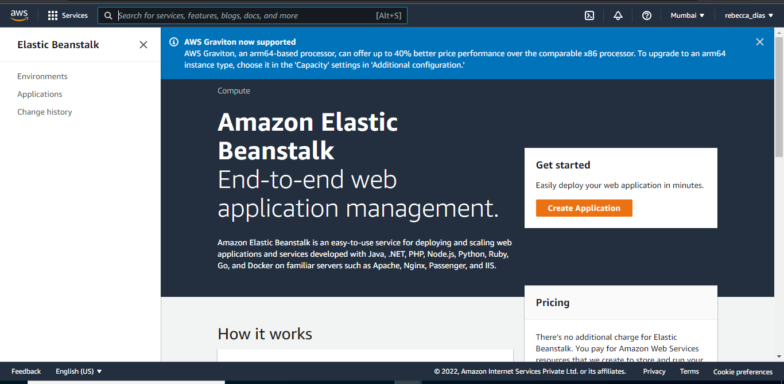

Click on Create Application ,

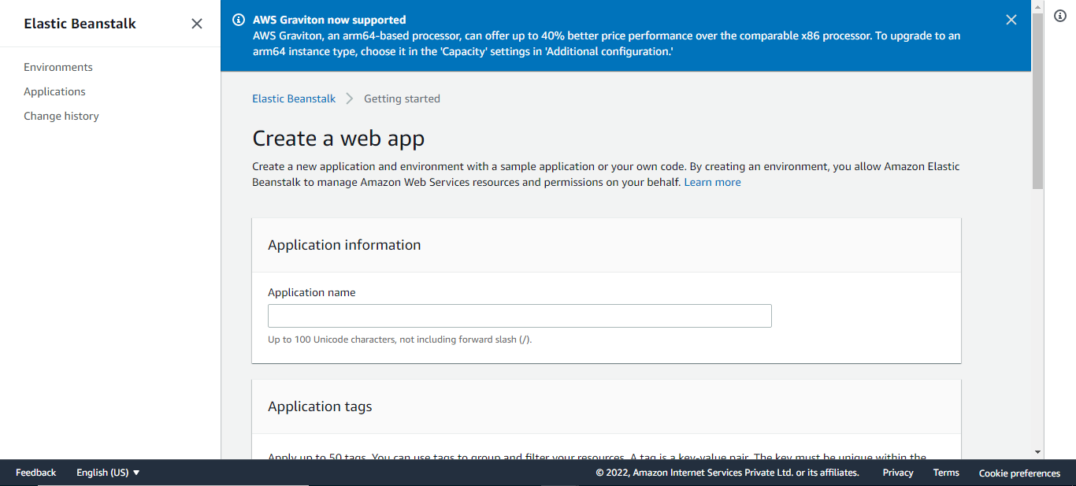

Give your application a name

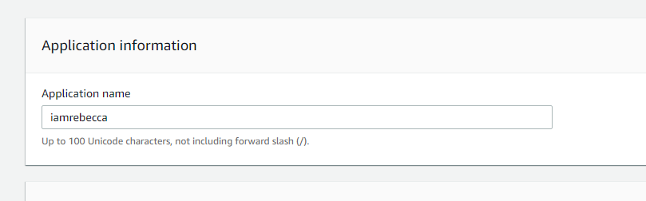

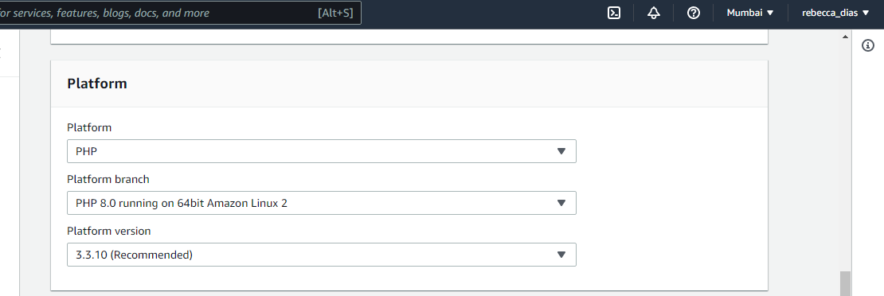

Set application Code as Sample and click on Create Application

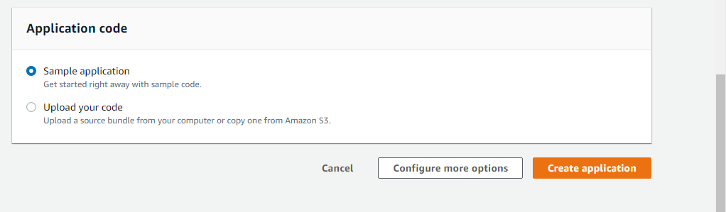

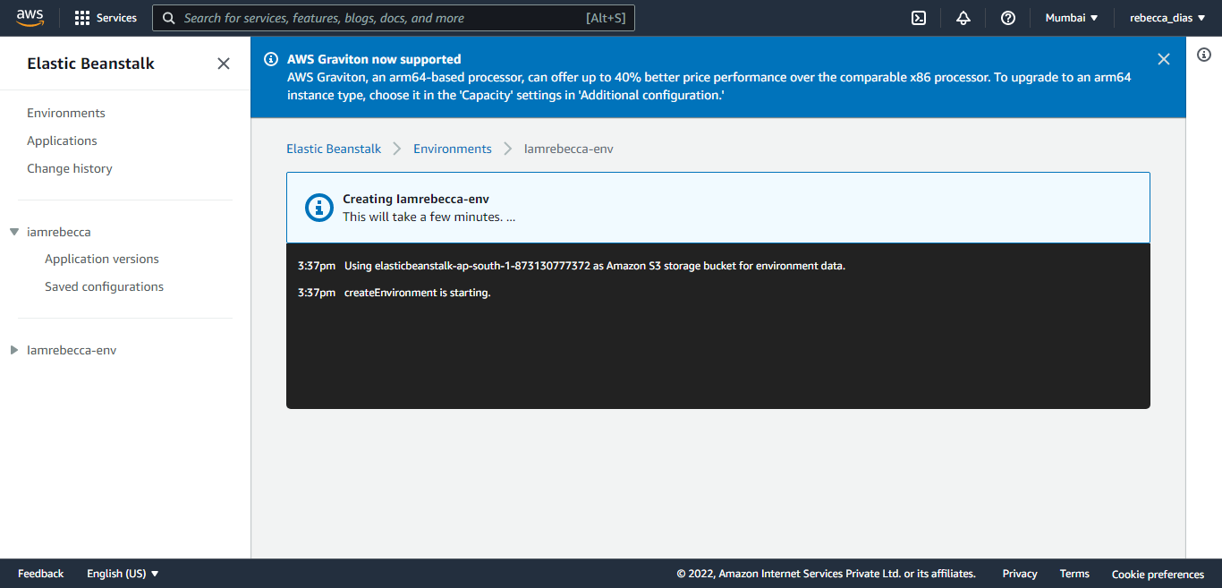

In the Ec2 Console check the running instance

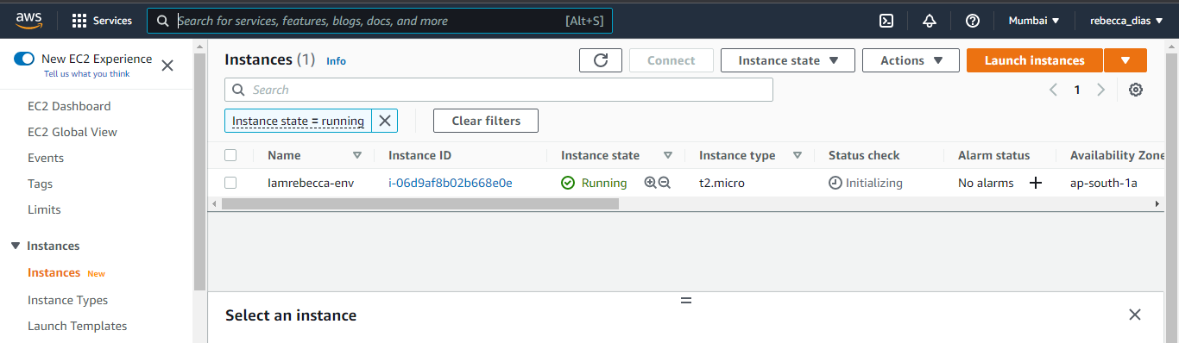

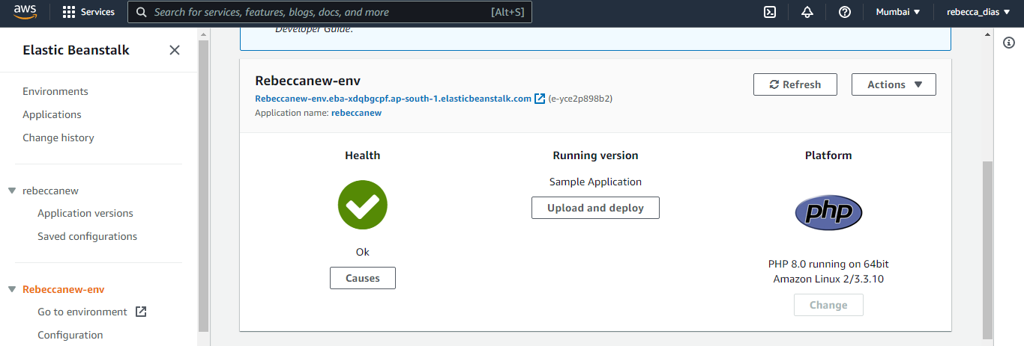

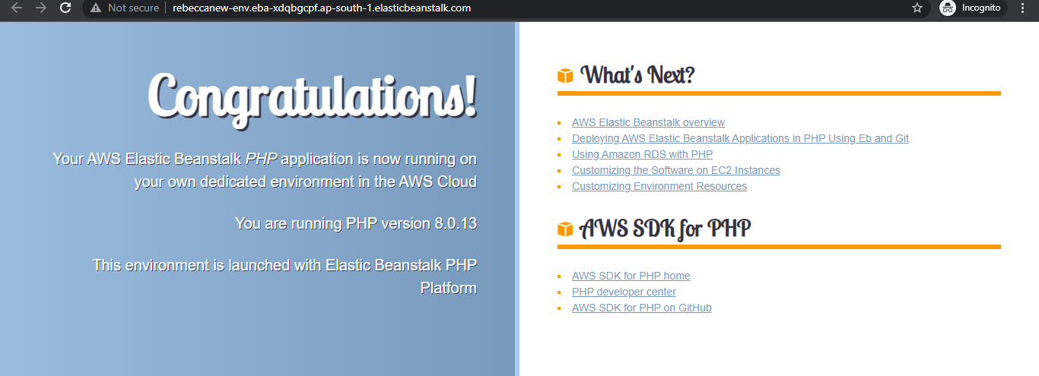

# Conclusion:

## What are the benefits of using Paas 1. Cost

All the companies which uses PaaS enjoy low investment cost since it does not require hardware and software. There is no expense involved in setting up and maintaining the software. The software can simply be used without needing to invest in infrastructure.

2. Availability

PaaS is made available to all the professionals irrespective of the location. As a result, the employees of an organization can communicate with each others using a single environment. For an example, different staffs involved in testing and maintenance can collaborate with each other to carry out their works from different locations. Thus, the PaaS is able to increase the employee productivity.

3. Scalability

The scaling mechanism behind PaaS makes it a reliable scalability solution. The environment used in a PaaS is highly scalable with resources and tools. The structure is flexible enough to allow business to expand without high investment. This is especially beneficial for small businesses looking to increase their resources and expand their service.

# References:

1. [What is PaaS? Platform-as-a-Service Explained | Sumo Logic](https://www.sumologic.com/glossary/paas/)
2. [Practical guide to PaaS: Benefits and characteristics](https://www.ibm.com/blogs/cloud-computing/2016/08/22/paas-benefits-characteristics/)
3. [What is PaaS? A simpler way to build software applications | InfoWorld](https://www.infoworld.com/article/3223434/what-is-paas-a-simpler-way-to-build-software-applications.html)
4. [6 Advantages and Disadvantages of PaaS | Drawbacks & Benefits of PaaS](https://www.hitechwhizz.com/2021/06/6-advantages-and-disadvantages-drawbacks-benefits-of-paas.html)